# Kitten viewer

## Topics: HTML, XHTML, CSS, JavaScript

Goals:

1. Create an HTML page that with a list of images, e.g. with kittens. Let it be 7 ones.
2. The active image (that you clicked on) must be enlarged. Not active ones must have the same smaller size.
3. The resulting page must be successfully validated by XHTML rules, i.e. via this service

https://validator.w3.org/#validate_by_upload

1. There must be a possibility to select images by pressing the buttons

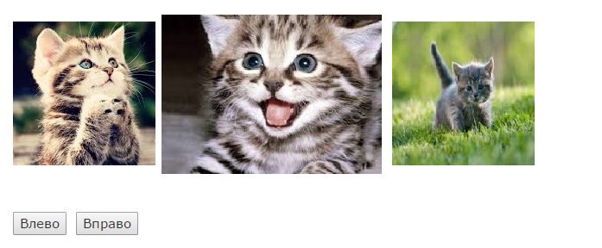

To the left

To the right

1. The selected picture must have a green border. Other ones must have yellow border.